

Project Plan - Sydney Airbnb Application

Viet My Tran Le s5235877- William Luvant s5287580 - Liangxian Zhao s2869753

Table of Contents

1.0 Introduction 2

1.1 Background 2

1.2 Scope 2

1.3 Document contents 2

2.0 Work Breakdown Structure 3

3.0 Activity Definition & Estimation 5

4.0 Gantt Chart 7

# Introduction

## Background

We are currently living in a technological world where data is an extremely crucial resource. Most of the information no matter how important they are, are contained inside databases. Moreover, we can collect information to create tables, statistics or even graphics to gain deeper knowledge and understanding regarding a situation or scenario. However, for normal human beings, it can be difficult for them to process and sort all the data. Fortunately, the rise of computers and AI help humans processing and sorting data easier. This project aims to help users group all information from the dataset given and analyse them to visualise them through the creation of a simple software tool. This software will be specifically created to process the dataset from "SYD AIRBNB Inspections".

## Scope

* The scope of this tool is to analyse and visualise the "Sydney Airbnb Inspections" dataset
* The main features are:
* Retrieve all properties listed within a user-selected period.
* Sort all properties according to the users' needs within a user-selected period.
* Retrieve all properties that contain a keyword that the user entered within a user-selected period.
* Analyse the properties’ cleanliness according to the customers comments and feedback
* Show the rating of properties based on the customers’ experience and their satisfaction toward the property.

## Document contents

This document contains the introduction of the project which includes the background of the project and its scope, a work breakdown structure, an activity definition and estimation and a Gantt chart based on the work breakdown structure defined.

# Work Breakdown Structure

Table 1 demonstrates Work Breakdown Structure to list every task that must be completed for the project. Each task in this list is allocated with a unique task ID and an estimated duration for each task. The work time is estimated to be 6 weeks and 2-5 hours per day. It is estimated that a total of around hours will be necessary to finish the building of the system and any future delivery.

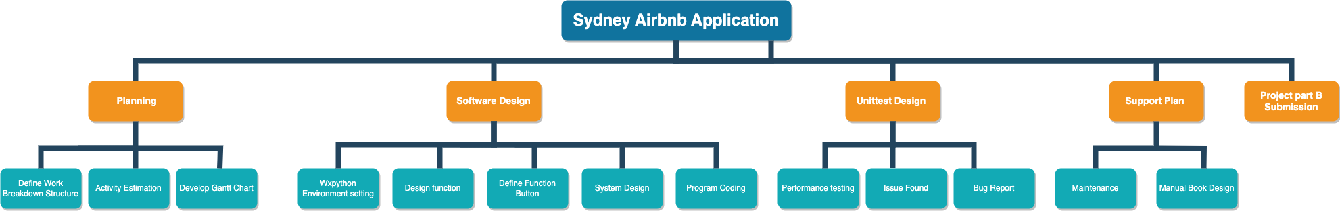

***Table 1: Work Breakdown Structure***

# Activity Definition & Estimation

|  |  |  |  |  |
| --- | --- | --- | --- | --- |
| **Activities** | **Definition** | | **Estimation** | |
| **1.Planning** | This activity is about getting to know the concept of the project and setting environment required to complete the project | | 1day | |
| 1.1 Define Work Breakdown Structure | This software project result-oriented work breakdown structure focus on project design, project management, analysis, designing, developing, and testing stages. | | 1day | |
| 1.2 Activity Estimation | Define structure and estimating duration needed to complete each activity | | 2days | |
| 1.3 Develop Gantt Chart | Creating a Gantt chart based on the work break down structure and activity definition and estimation | | 1day | |
| **2. Software Design** | This process encompasses various aspects, including choosing appropriate algorithms, data structures, and design patterns, as well as considering factors like scalability, maintainability, and user experience to ensure the software meets its intended purpose. | | 2days | |
| 2.1 Wxpython Environment setting | wxPython serves as a graphical user interface (GUI) toolkit compatible with Python. Python developers can efficiently build applications with robust and feature-rich graphical interfaces.  The setup pertains to the developer's local desktop or workstation, known as the "local environment." In this environment, code is developed, problems are addressed, and developers perform unit tests independently and in isolation. | | 2days | |
| 2.2 Design function | Defined as a software feature based on the client's specifications. | | 2days | |
| 2.3 Define Function Button | Retrieved by time- user retrieved data by timeframe.  House price trend- user retrieved price by bar chart.  Keyword searching-user searching keywords.  Keyword of cleanness-user check cleanness by searching keywords  Score rating- property score rating | | 5days | |
| 2.4 System Design | The components of software design are listed:     * User opens app * User chooses function * (If needed) User enters time period/keyword/etc * App displays analyzation and visualization of “Sydney Airbnb Inspection” dataset with chosen function and customization by user * User chooses to close app or to do another sessions | | 2days | |
| 2.5 Program Coding | It involves translating the logical steps and algorithms designed during the software design phase into actual lines of code that a computer can understand and execute. Programmers use programming languages like Python | | 5days | |
| 3 **Unit test Design** | Unit testing is conducted prior to code distribution to ensure it meets the necessary quality standards. It plays a significant role in the software development process, as it assists developers in producing higher-quality code efficiently and has the potential to identify and address bugs. | | 4days | |
| 3.1 Performance testing | Initial test of program implementation | | 1day | |
| 3.2 Issue Found | After conducting multiple test runs, medium or low priority that cannot be addressed due to time constraints. | | 2days | |
| 3.3 Bug report | It provides a clear record of issues, enable developers to reproduce and fix problems, and help teams prioritize and manage bug-fixing efforts. Clear and detailed bug reports contribute to the overall improvement of software quality. | | 1day | |
| **4.Support Plan** | Implement a version control system like Git to manage source code changes, collaborate among team members, and track code history. | | 1days | |
| 4.1 Maintenance | Comprehensive maintenance to provide full support for software implementation | | 1days | |
| 4.2 Manual Book Design | Written document that provides instructions, guidance, and information on how to use, operate, assemble, install, or troubleshoot a product, device, software application, or system. | | 1days | |
| **5 Project part B Submission** | Submission assignment part B | | 1days | |
|  |  |  | |  | |

***Table 2 Activities definition& Estimate***

# Gantt Chart

Figure 1 illustrate the estimated work breakdown structure as visualized Gantt chart. The task duration and work date are designed for project schedule arrangement. The Gantt chart document can be attached on Gitlog.

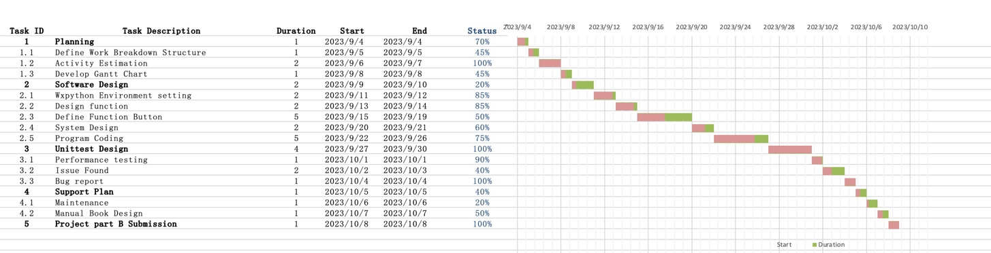

***Figure 1. Gantt chart***